# NLP Assignment #1 Report

Submitted by:

Jigna Reshamwala [425008356]

This report contains details about NLP Assignment#1. I have modified SpamLord.py to match the email and phone number patterns in the given files.

I could achieve following results: tp=59, fp=0, fn=0

1. ***How to compile and run the code***

My code is tested for Python 2.7.12. It might give errors with Python 3.

To compile and run the code following are the two methods:

Using IDE

* Import the project in any Python IDE
* Edit Run Configurations and set script parameters to:

"data_dev/dev/" "data_dev/devGOLD

* Run the script to get the output

From Terminal

* Open Terminal
* Go the the folder NLP_HW1
* Type in the following command:

python SpamLord.py data_dev/dev/ data_dev/devGOLD

1. ***Results and Analysis***

I have attached the results screenshot:

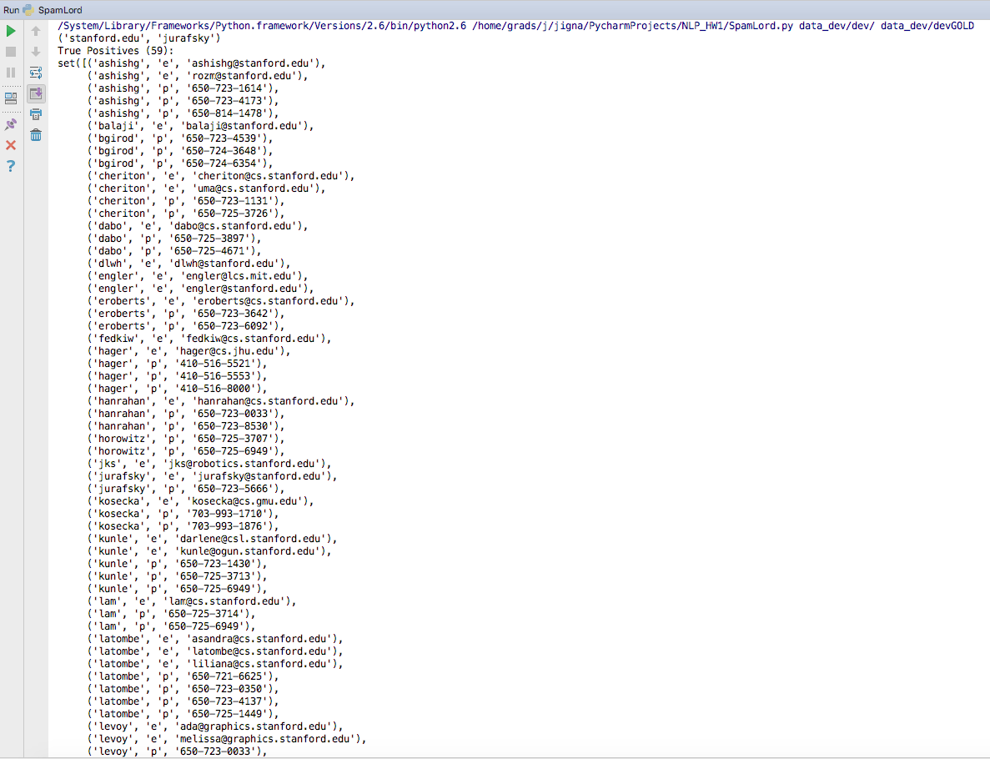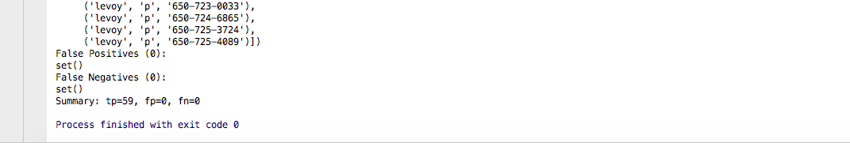

Additionally, I have also tested for following tests:

<a href="contact.html">TEL</a> +1&thinsp;979&thinsp;862&thinsp;2908

huangrh(at)cse.tamu.edu

huangrh at cse dot tamu dot edu

1. ***Any known bugs, problems, or limitations of the program***

The code can handle all the patterns of email and phone numbers give in the test case. There are no limitations as such. But I have used two patterns for matching email corresponding to following two types:

huangrh@cse.tamu.edu

huangrh@tamu.edu

While working on this assignment, I got to learn a lot about regex. I really found it useful and enjoyed doing it.